Set up Satellite Server using third party Foreman & Katello repository.

Step 1. Download the Rhel 9.6 ISO .

Step 1: Verify OS and hostname

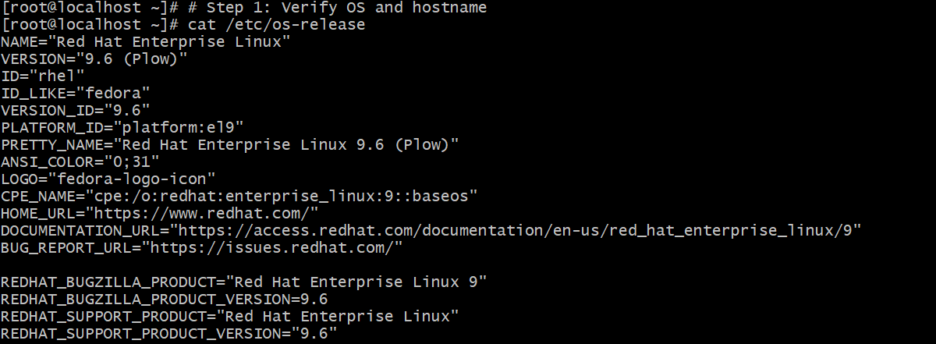
Set FQDN (example):

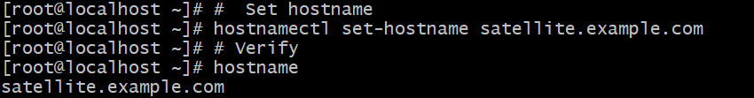

Update /etc/hosts

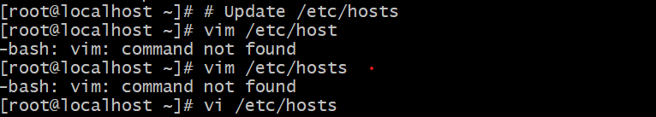

Add

192.168.0.129 satellite.example.com satellite

Step 2: Configure static networking

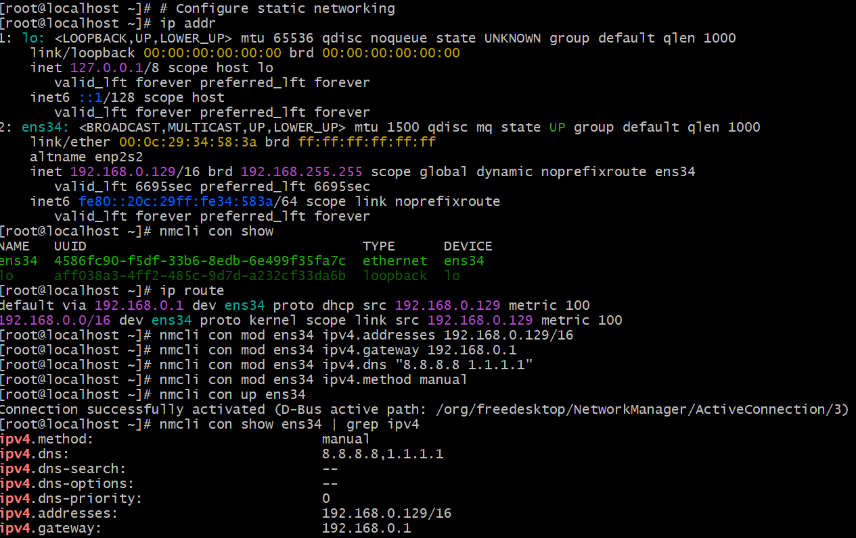

Step 3 Update the system.

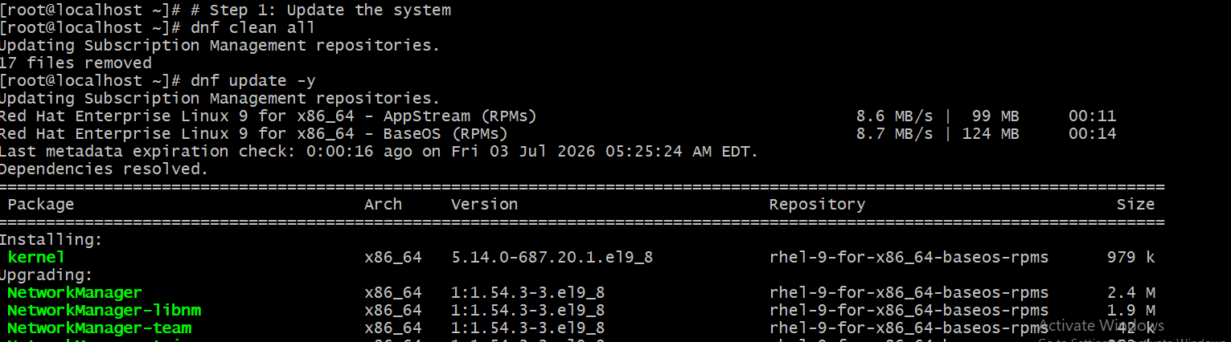

Configure time synchronization

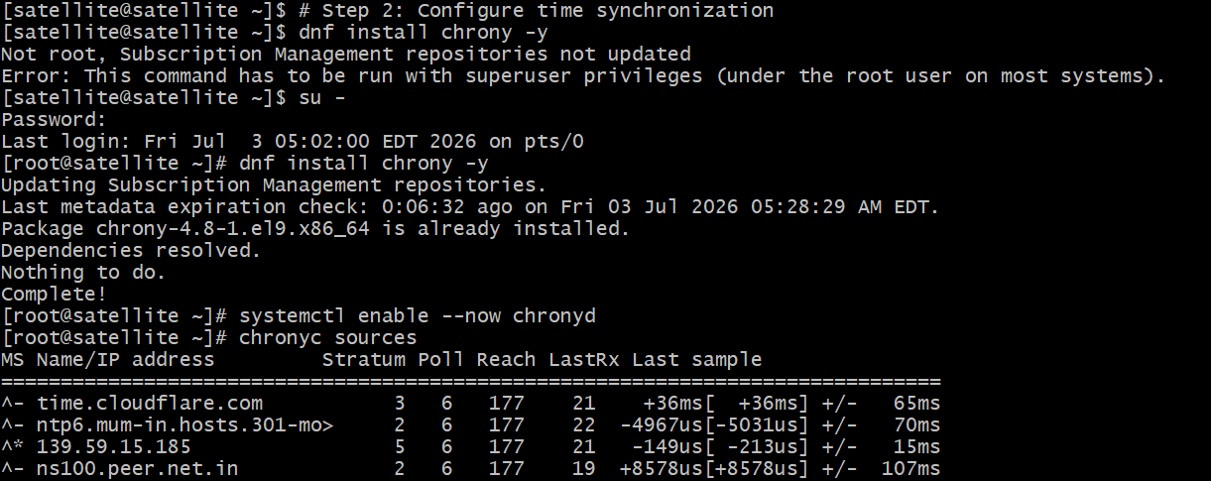

Configure firewall

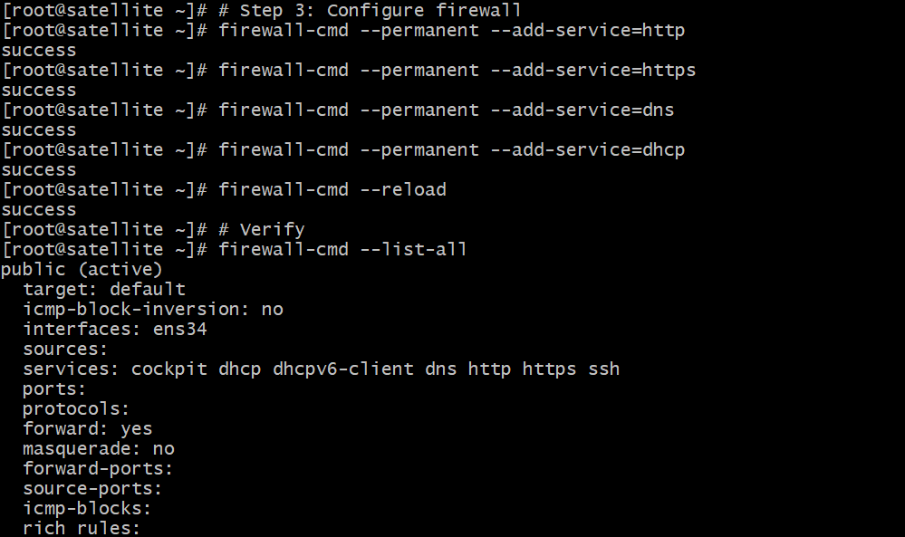

Install Foreman repository

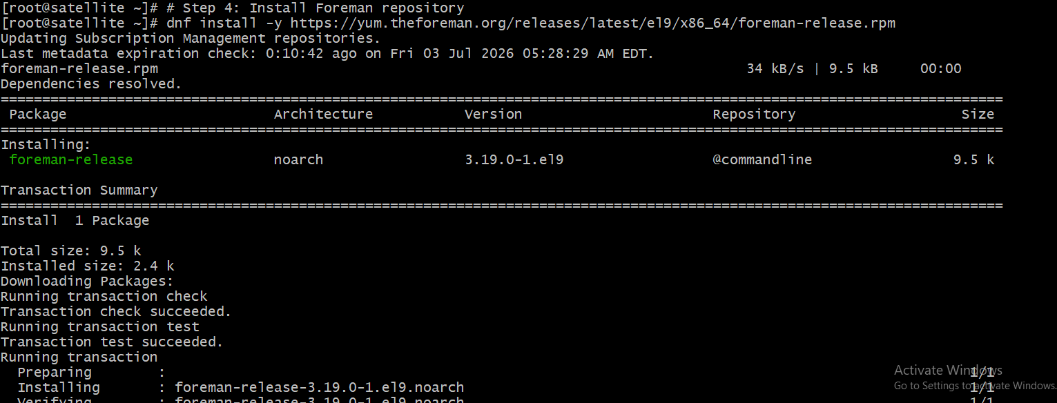

Install Katello repository

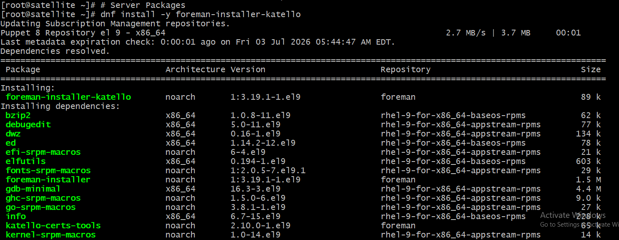

Run the installer

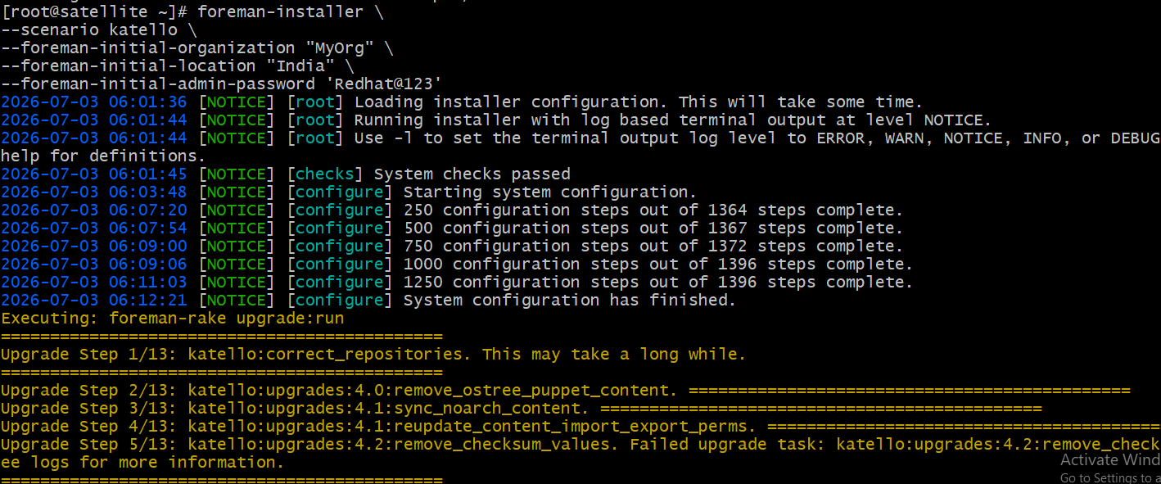

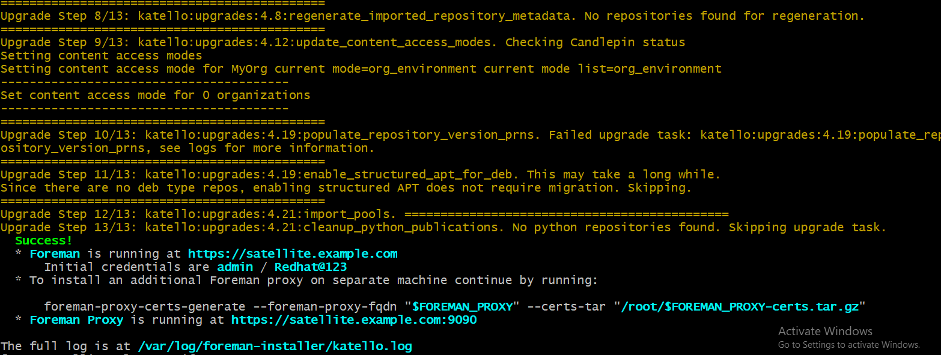

Verify services

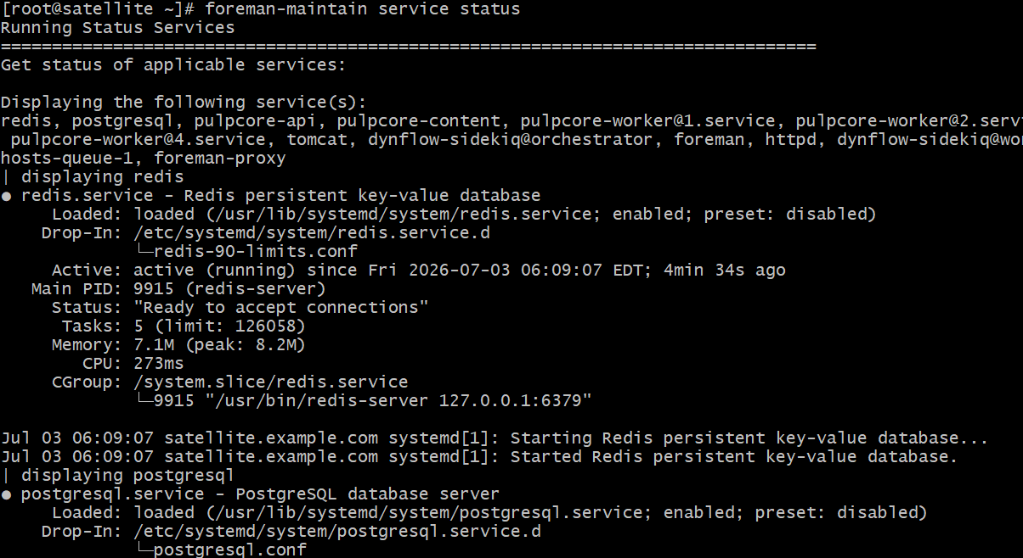

Access the UI

https://192.168.0.129 & login using username admin password Redhat@123

